How to use RCOUNT to display the total number of rows in an Analytics report | 

Yoel Kortick
Senior Librarian

There may be cases where a user will want to know how many rows are in his report. Rather than exporting the report to Excel and checking the number of rows the following may be done.

Here are the steps. Below it is shown in depth

- Add a column to the existing report (can be any criteria)
- Edit the column properties and change the formula to be "MAX(RCOUNT(1)) "
- Edit the column properties then click Column Format and hide the column with the check box in the top right corner.
- Change to the results tab and click on the New View icon (rectangle with plus sign) then select Other Views --> Narrative. This adds a footer to the report.
- Click on the pencil icon in the Narrative footer.
- In the box labeled narrative enter " Total number of rows: @1" (in this example we use “1” because this is the position of the column added in step 1. Substitute the “1” for a different number if you have the field added in step 1 above in a different column. In the “rows to display” field put “1”.

ONE
Here is our report

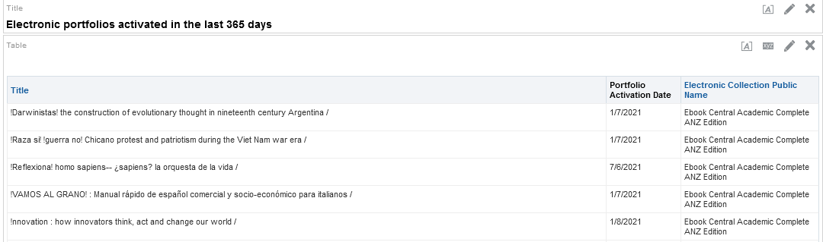

Add any field to the report. Here we added portfolio ID

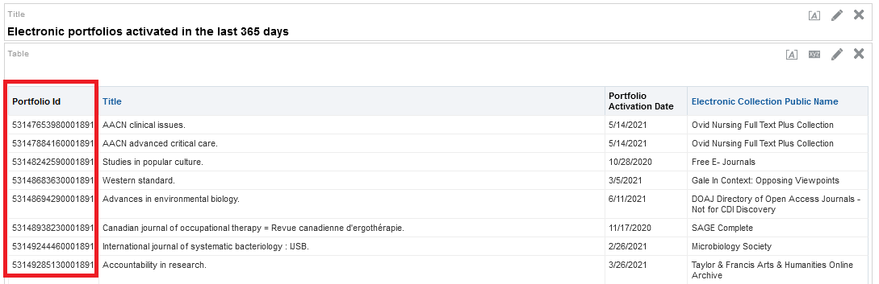

TWO

Edit the column properties of the new column and change the formula to be "MAX(RCOUNT(1)) "

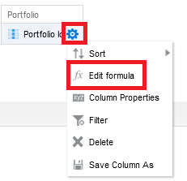

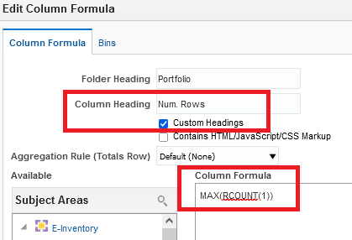

THREE

Edit the column properties then click Column Format and hide the column with the check box in the top right corner.

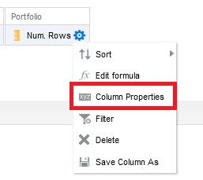

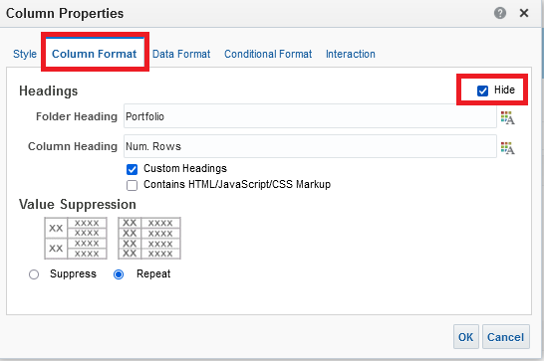

Note that in the criteria tab the column with the number of rows is in position 1 (the 1st column). This is important for later when we “call it” do display in the results.

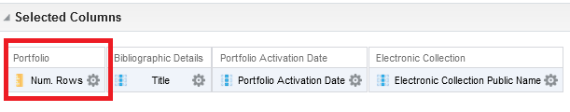

FOUR

Change to the results tab and click on the New View icon (rectangle with plus sign) then select Other Views --> Narrative. This adds the narrative to the bottom of the report.

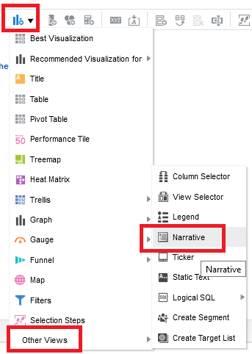

FIVE

Click in the pencil icon in the narrative

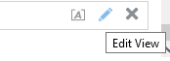

SIX

In the box labeled narrative enter " Total number of rows: @1" (in this example we use “1” because this is the position of the column added in step 1). Substitute the “1” for a different number if you have the field added in step 1 above in a different column. In the “rows to display” field put “1”.

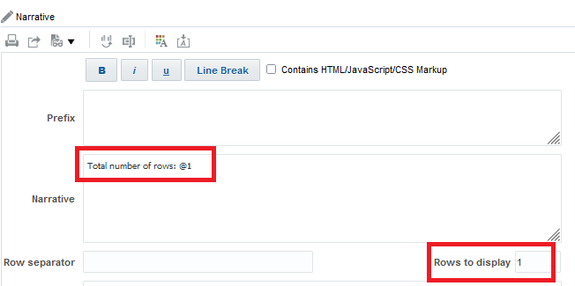

SEVEN

Now we have this on the bottom of the report (and we can drag to another place in the report if desired).



EIGHT

Now we dragged the narrative to the top and exported the report:

